COMP 3329 Project Report

Year: 2019/20 Semester 2

Group Number: 27

Member: Chan Wang Leung

Game Title: CardVersi

Contents

1. Introduction, Background and Inspiration
2. Complete Game Rules
3. Game Features
4. Self evaluation
5. **Introduction, Background and Inspiration**

The name of the game “CardVersi” is blended from “card” and “reversi”, which is a well-known 2-player board game. The 2 players places a stone on the board on their turn, back and forth, until the board is full and cannot accommodate any more stones. The interesting part about reversi is its capture rule, if any stones of the opponent’s color that are in a straight line and bounded by the stone just placed, those stones are turned over (“captured”) to the current player’s color.

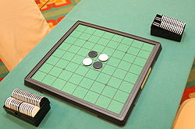 Image of a starting Reversi position

This game basically uses cards to replace the stones of reversi, and the board is also shrinked. This game also took inspiration from a Final Fantasy minigame- Triple Triad. Plenty of elements from the minigame is referenced in CardVersi.

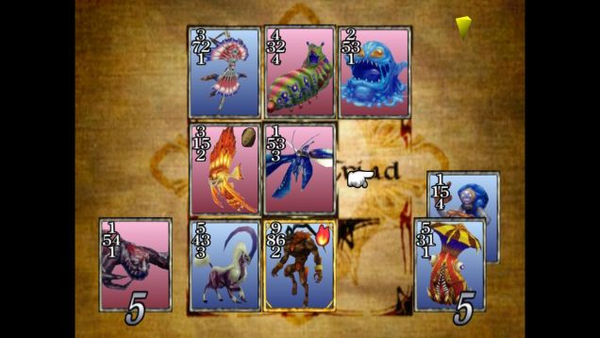Image of TripleTriad gameplay

1. **Complete Game Rules**

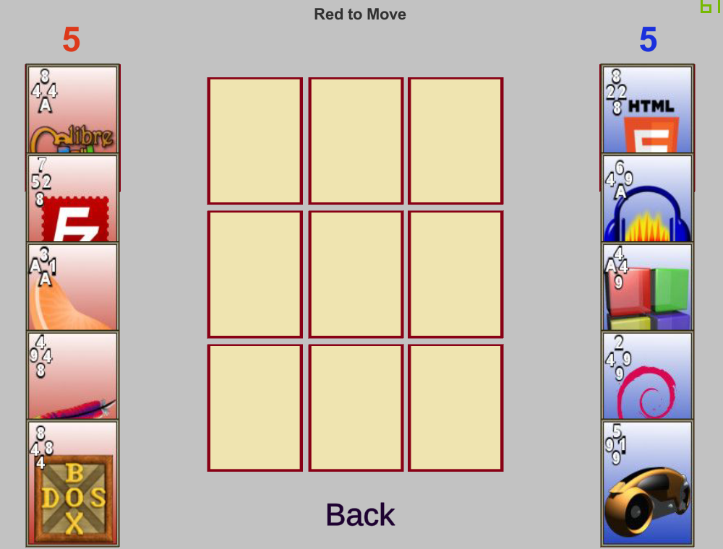

(Above, Sample Starting Position)

When the game commences, each player will be given five cards. Player with the red cards will begin first. The first player can click on a card to play anywhere on the 3x3 board. After the first card is played, the opponent may play a card on any unoccupied space on the board. The game will continue with player’s alternating turns, until all 9 squares on the board have been occupied.

**Winning**

To win the game, a majority of the total ten cards played(including the one card that is not placed on the board) must be of the player’s color.

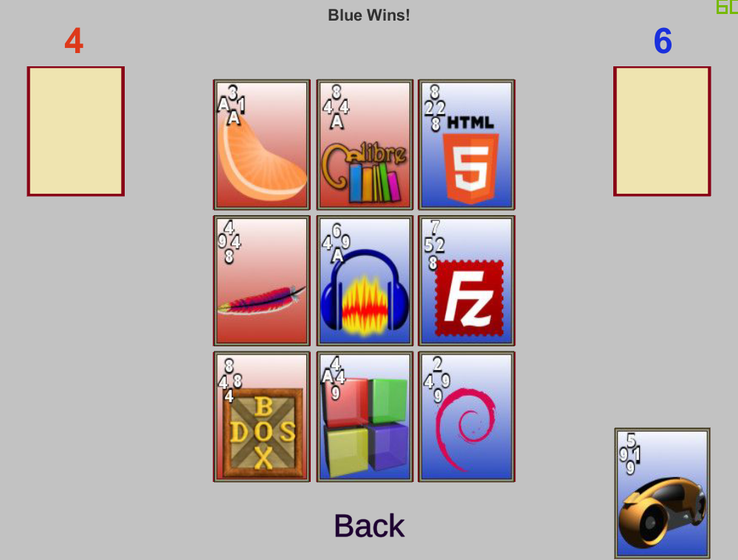

(Above, Blue wins here because cards with the color blue vs red is 6 to 4)

**Cards**

The 4 numbers on the top left corner of a card corresponds to the four sides of the card, each number represent to strength of each side, ranging from 1 to 9, A is equal to 10.

There are 18 cards in play and each game 10 of them will be distributed randomly to players each game.

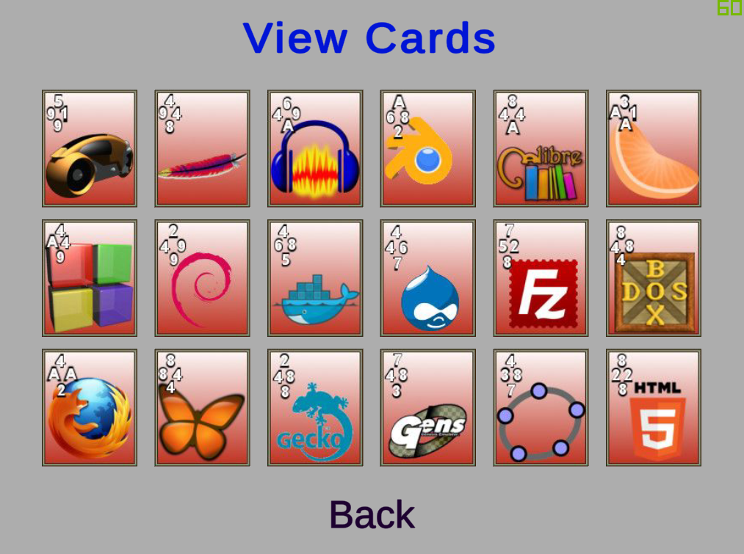

(Above, all 18 cards in play)

**Capturing**

To capture a card, the active player places a card adjacent to the opponent’s card. If the rank touching the opponent’s card is higher, the opponent’s card will be captured and the color of the card will be changed in to the active player’s color. There is no limit on how many times a card can be captured.

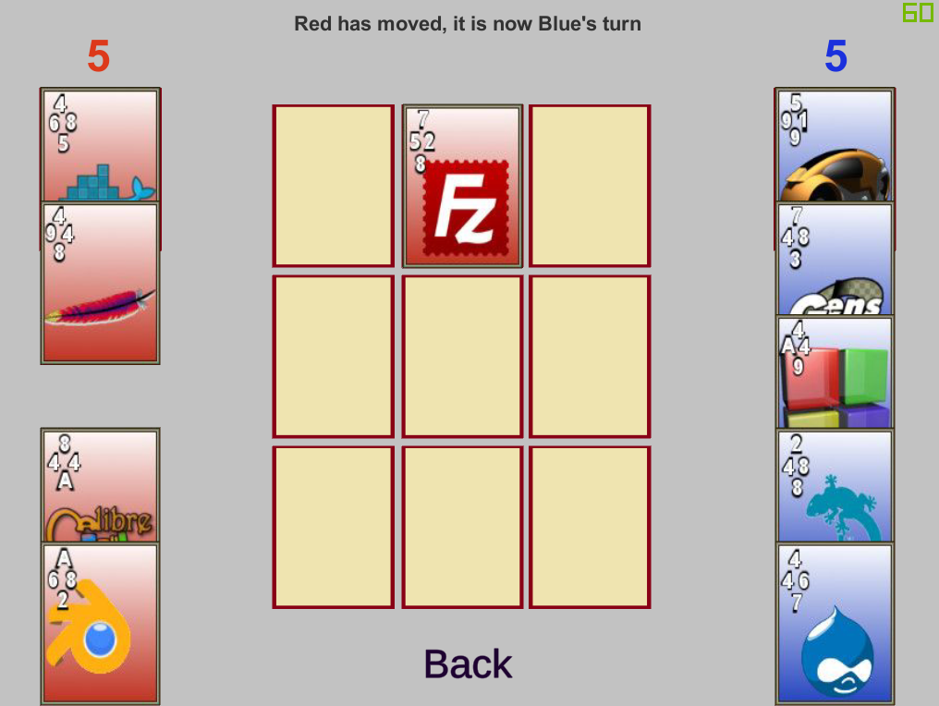

(Figure 1, Red plays a “top7 right2 bottom8 left5”)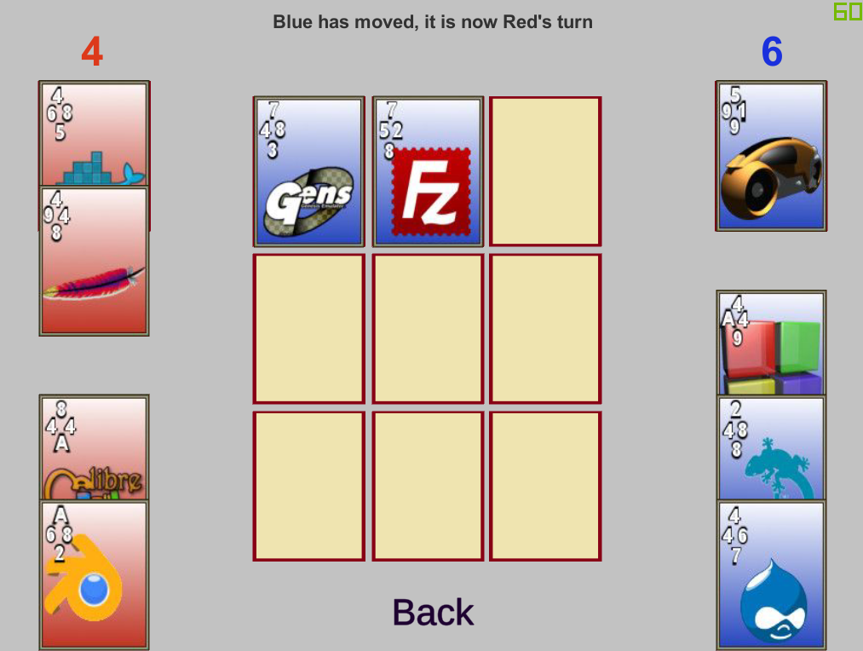

(Figure 2, Blue plays a “top 7 right 8 bottom 3 left 4” card on the left of the card red played. Since they are adjacent to each other, the rank of the side touching will be compared. In this occasion, since 8 > 5, blue is said to have captured red’s card)

1. **Game Features**

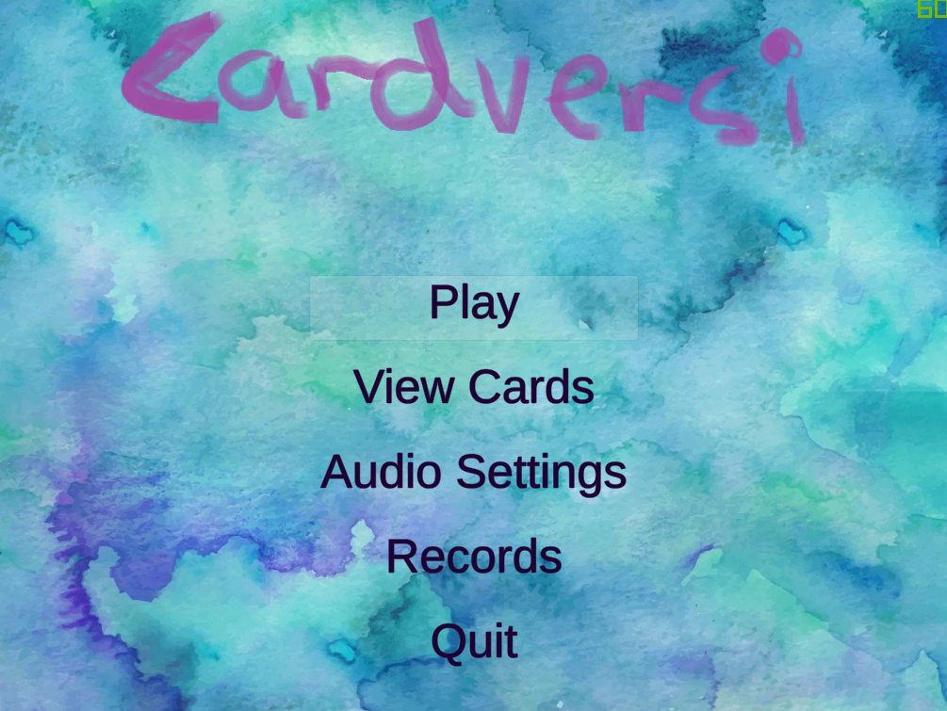

(Above, main menu of game)

* Play  
  initiates a new game
* View Cards  
  allows user to see all 18 cards in play
* Audio Settings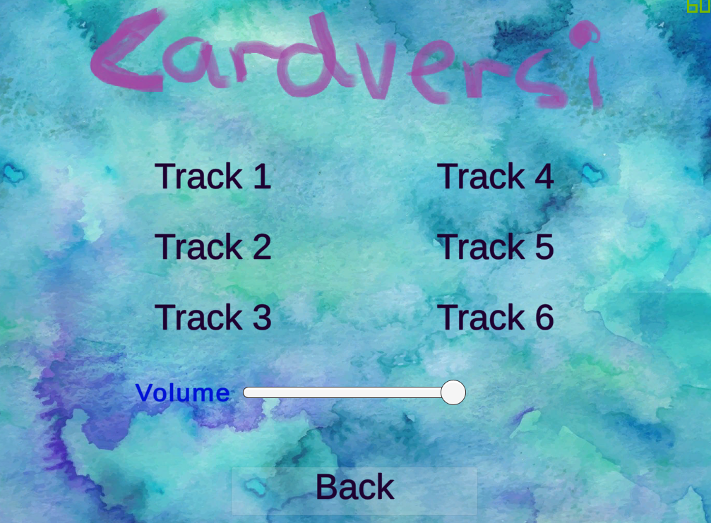

There are 6 different soundtracks in the game:

Track 1: Bach BWV850

Track 2: Bach BWV848

Track 3: Mozart K314

Track 4: Dvorak Op.33

Track 5: Tchaikovsky Nutcracker Suite

Track 6: Bach BWV1001

The Volume bar is fully adjustable, increasing volume from left to right.

* Records  
  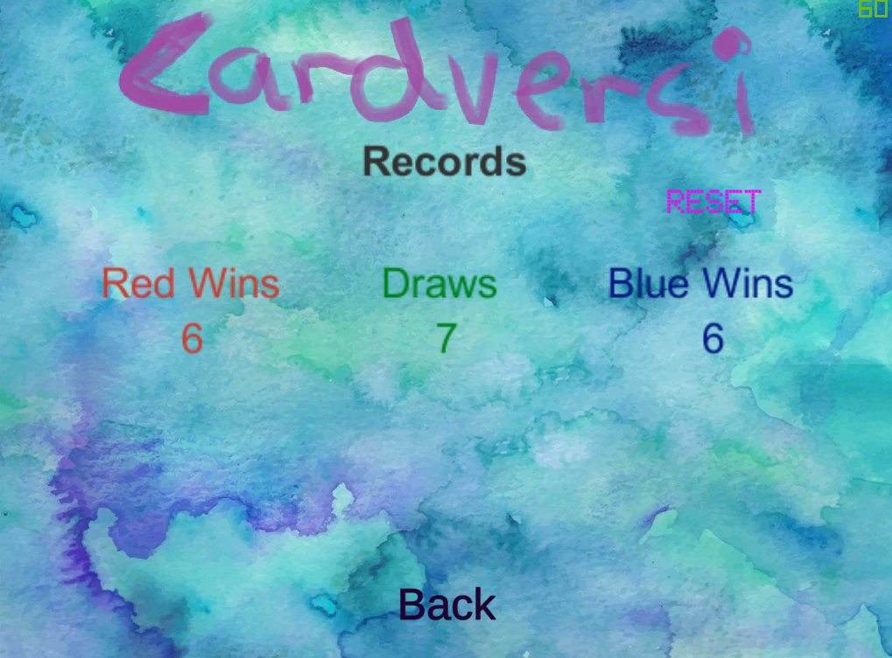

The Records menu shows the total number of red wins, draws and blue wins.

Clicking the RESET button will reset all the records to 0, for first initiation of the game, it is highly recommended to press it once then restart the application again.

* Quit  
  ends the application

1. **Self Evaluation**

Improvement ideas

* More cards
* More than 2 players
* Networking Implementation
* More game modes